**Ditch Resources Web Mapping/Website Project**

First Draft — April 15, 2021

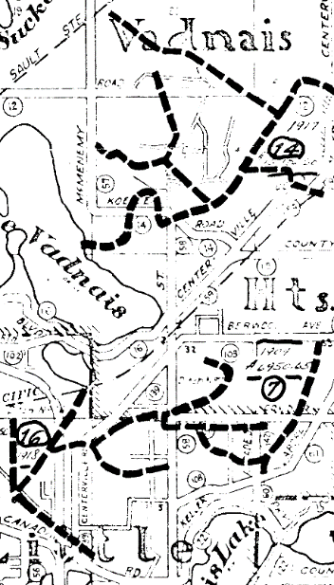**Project Overview.** Ramsey County contains a number constructed open ditches and sub-surface tile ditches that were established in the early part of of the 20th Century. Originally important for draining swampland, creating arable lands, removing stagnant water and insect control, these ditches still remain in use as a key resource for surface water management purposes.

Since the 1970s, Ramsey County has been gradually transferring ownership and management of these dtiches over to the various watershed districts and watershed management organizations which operate in the County.

This project entails the the creation of standardized geospatial data for all ditch resources in Ramsey County and the creation of a publicly-facing web site for historical and contemporary information, including on-going inspection reports in a centralized, easy-to-use resource.

**Purpose and Need.** At present, there are a large number of files—both historical and contemporary—associated with each ditch in Ramsey County. As these ditches remain an important resource for surface water management and as continual ditch inspections are taking place, having a centralized location for all these resources to be well organized and readily available is desirable. Staff at Ramsey County, watershed managemnet units, municipalities and consulting engineers frequently require access to these files for reference for their various projects.

Additionally, a complete and accurate set of geospatial data representing these ditch resources does not presently exist. This project will entail the collection, creation and assembly of standardized geospatial data for all ditch resources within Ramsey County. This data will be made freely and openly available from the website as a resource material to the interests and agencies listed above.

**Method and Deliverables.** Staff from Public Works and Information Services will share tasks and responsibility for the successful oversight and deployment of the effort. Key actions and deliverables for the effort are as follows:

* Organization of the inventory of existing dtich archival files and materials into a centralized repository/folder structure;
* Assembly and publishing of a consistent and standardized geospatial dataset of the active and abandoned ditches present in the County;
* Creation of a master county-wide map of both active and abandoned ditch resources; this map will be available as both as a downloadable static PDF and interactive web map;
* Creation of an easy-to-use web interface where the user can easily navigate to the historical and contemporary files they need regarding ditches in the County;

**Technology.** For the execution of this project, the Information Services Department proposes the use and deployment of the ***ArcGIS Experience Builder*** platform, as this platform can integrate both web maps and data records and provide an attractive and easy-to-use user inteface experience.

**Development and Approval Process.** Information Services GIS Unit Staff will begin mocking up draft versions of the archive repository, map, dataset and web interface and provide these to Public Works staff for their review and approval. The project will take on an ‘iterative and incremental’ approach of draft creation, draft review, corrections and approval to ensure the Public Works department is getting what it needs from the project delivery.

**Tasks and Timeline.** The following general set of tasks and timeline is applied to the project, subject to the review and approval of Public Works Staff:

**Spring 2021 (April-May):**

* Assembly of archival materials into a central file folder repository

***(Currently In Progress)***

* Creation of a complete GIS dataset of all active and abandoned ditch resources in Ramsey County

***(Currently In Progress)***

* Creation of a county-wide ditch resource basemap (PDF and web map), including:
  + Active and abandoned ditches in Ramsey County
  + Municipal boundaries
  + Watershed management unit boundaries
  + Ditch drainage capture areas
  + Hydrology features
  + Major road networks
  + Public Land Survey System grid
  + Other landscape features as requested and desired by Public Works
* Creation of initial mock-ups of the web site resource for the review and approval of Public Works staff

**Summer 2021 (June-July):**

* Revision of above listed materials as per the direction of Public Works staff;
* Documentation/training for staff on how to load new materials (inspection reports) to the web site;
* User experience testing, revision and refinements as requested and desired by Public Works staff;
* Approval and sign off on web resource;

**Anticipated Goal Launch Date of Ditch Resources Website: Monday, August 2, 2021**

**Key project staff contacts:**

**Project Owner:**

Molly Churchich, Environmental Services Supervisor

Public Works

651.266.7159

[molly.churchich@ co.ramsey.mn.us](mailto:molly.churchich@%20co.ramsey.mn.us%20)

**Project Technical Lead:**

Geoffrey Maas, Senior Geospatial Business Analyst

Information Services

651.266.3465

[geoffrey.maas@co.ramsey.mn.us](mailto:geoffrey.maas@co.ramsey.mn.us)