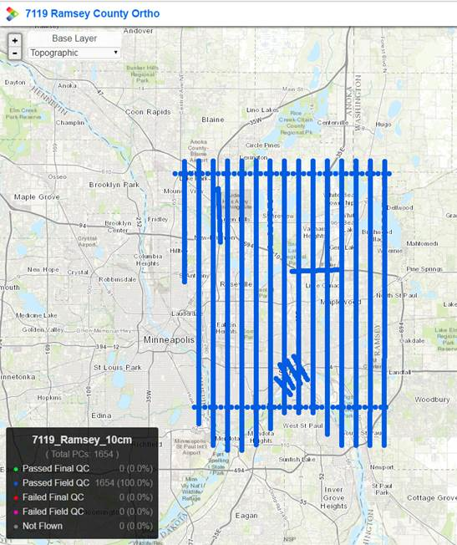

Imagery collection on April 6, 2017